

**REPUBLIC OF CAMEROON**

PEACE-WORK-FATHERLAND

THE UNIVERSITY OF BUEA

P.O Box 63,

Buea,South West Region

Cameroon

**FACULTY OF ENGINEERING AND TECHNOLOGY**

**Department of Computer Engineering**

**CEF 440: INTERNET PROGRAMMING AND MOBILE PROGRAMMING**

**UI DESIGN AND IMPLEMENTATION OF A MOBILE BASED APPLICATION FOR ARCHIVAL AND RETRIEVAL OF MISSING ITEMS**

PRESENTED BY: **GROUP 21**

**2rd Semester**

**2023/2024 Academic Year**

**COURSE INSTRUCTOR**

**Dr. NKEMENI VALERY**

|  |  |  |
| --- | --- | --- |
| **S\N** | **NAME** | **MATRICULE** |
| **1** | **AKENGNI KEANLI EMMANUEL** | **FE21A132** |
| **2** | **CHOMOH SYLVIA FONCHENALLAH** | **FE21A162** |
| **3** | **MBI AYAMBA DIANNA** | **FE21A230** |
| **4** | **NGAUEN NDJOMOU LOICE VANELLE** | **FE21A258** |
| **5** | **NGOBA STEVE JONES NTONSG** | **FE21A259** |

**Table of Content**

1. INTRODUCTION-----------------------------------------------------------------4
2. UI DESIGN-------------------------------------------------------------------------4
   1. Design principles---------------------------------------------------------------5
   2. Color Scheme------------------------------------------------------------------5
   3. Typography--------------------------------------------------------------------6
   4. Icons and imagery-------------------------------------------------------------7
3. PAGE DESCRIPTION-----------------------------------------------------------9
4. IMPLEMENTATION-----------------------------------------------------------13
5. CONCLUSION-------------------------------------------------------------------14
6. **INTRODUCTION**

The purpose of this report is to detail the design and implementation process of the user interface (UI) for a mobile application focused on archival and retrieval of missing items using image matching technology. The app aims to provide users with a seamless and intuitive experience for reporting lost items and searching for them through image recognition**.**

This report is going to entail the step by step processes and choices taken for the design and implementation of the user interface as well as the fundamental reasons behind them.

1. **UI DESIGN**

The UI design of this "Lost to Found" app emphasizes simplicity, intuitive navigation, and visual appeal. It features a clean and minimalist layout with easy access to key functionalities such as searching for lost items, reporting found items, and browsing through a gallery of found items. The design prioritizes user-friendliness and efficiency, with a focus on guiding users through the process of locating lost items using image matching technology. Overall, the UI design aims to provide a seamless and engaging experience for users searching for and reporting lost items.

Understanding the target audience is crucial for designing an effective UI. Extensive user research was conducted to gather insights into user preferences, behaviors, and pain points related to lost item retrieval. Surveys and interviews were conducted to identify common challenges faced by users when trying to locate missing items.

2.1. **Design Principles**

* Simplicity: The UI of this app is designed to simple using likable and universal colours like blue and white, which complicates the application less for the users
* Unity: Crating a sense of harmony between all the elements in a page. This creates a sense of unity when all the elements are conceptually arranged together. This ensures that the concepts being communicated are clear and cohesive. We did however introduce some variety to create a balance between a dynamic and chaotic design
* Hierarchy: There is a perceived order of the various elements included in each page which is aimed at highlighting the most important elements
* Rhythm: All the elements of this UI design were consistent in shape, size and color which intuitively guides the user.
* Balance: Coherent rules applied to fonts, color, size, gives a more beautiful and balanced interface.

2.2. **Color Scheme:**

Primary color: Blue

Secondary colors: white and Sky Blue

The "Lost 2 Found" app utilizes a color scheme comprising blue, white and sky blue. This choice is aimed at enhancing user experience and ensuring the app's effectiveness in helping users archive and retrieve missing objects.

**Reason for Color Choice:**

* Trust and Reliability:

Blue is universally associated with trust, reliability, and security. It instills confidence in users, making them feel their information and activities on the app are safe and secure.

* Calmness and Clarity:

Sky Blue evokes feelings of calmness and serenity. It helps reduce user stress, which is particularly important when dealing with the anxiety of lost items.

* Visual Hierarchy and Contrast:

The combination of blue and sky blue provides a subtle yet effective contrast, ensuring important elements stand out without overwhelming the user. This visual hierarchy helps users navigate the app efficiently.

* Consistency and Professionalism:

Maintaining a consistent color palette throughout the app enhances the overall aesthetic and user experience. It presents a professional and polished interface that aligns with the app's purpose.

* Focus and Readability:

Blue tones are easy on the eyes, reducing strain during prolonged use. This is crucial for an app where users might spend considerable time searching for and reporting items.

2.3. **Typography:**

Typography Selection: Clear Fonts with Minimal Text

The typography used in this app is designed to enhance readability, user engagement, and overall user experience. The chosen fonts are clear and straightforward, complemented by the strategic use of minimal text and a catchy slogan: “You lossam, we findam.”

**Rationale for Typography Choice:**

* Clarity and Readability
* Minimal Text for Maximum Impact
* Engaging Slogan:

The slang slogan, “You lossam, we findam.” is prominently featured. It is concise, memorable, and adds a touch of personality to the app. This informal phrase resonates with users, making the app feel approachable and user-friendly.

* Consistency:

Consistent use of typography throughout the app ensures a cohesive look and feel. This consistency helps users become familiar with the interface quickly, improving overall usability.

* Aesthetic Appeal:

The clean fonts and minimalistic text contribute to a modern, professional aesthetic. This enhances the visual appeal of the app and aligns with the clean design ethics.

2.4 **Icons and imagery**

The icons and imagery used are designed to be simple and easily recognizable. This ensures quick identifiable functions and easy to navigate the app without confusion. Dis engaging icons and images also contribute to a more interactive and enjoyable user experience.

In the "Lost to Found" app, various icons are used to enhance usability and provide clear visual cues for different functions. Here are some of the key icons used:

**ICONS**



Home screen Search User profile



Notifications Input image (lost/ found) Back icon

**IMAGES**

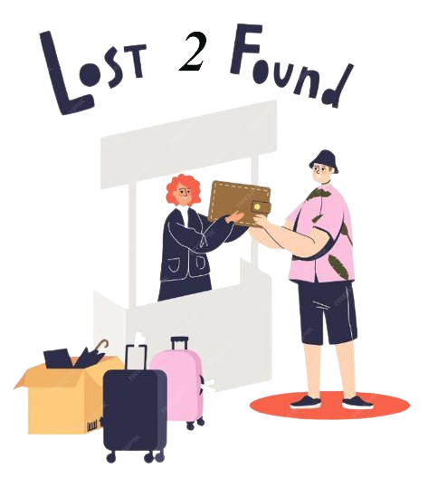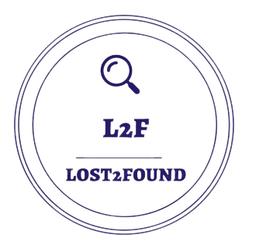

App Logo Visualizes return of lost item Contact us





Search of missing items Represent support and customer service

1. **PAGE DESCRIPTION:**

Providing a detailed description of all pages of the application. They are as follows:

* Welcome page

The first page on the application including the app’s logo, welcome message and the apps slogan “you lossam, we findam!” which is meant to capture the attention of the user and retain them..

* Sign in /sign up page

Including simple and clear instructions to help the user create an account or gain access to their already existing account. With minimal but clear words for simplicity

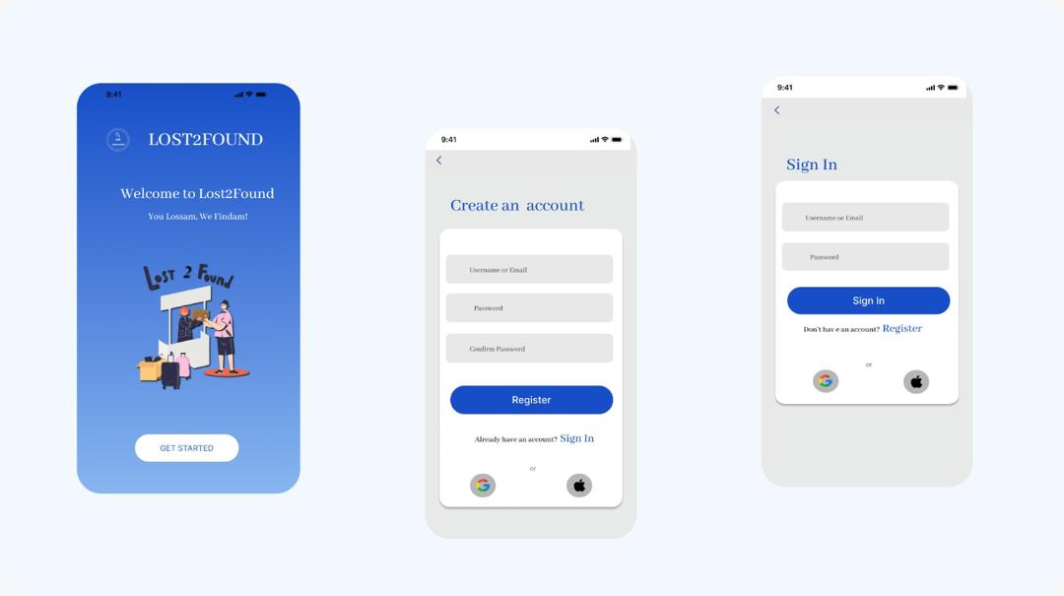

* Home page

Evokes the user’s eyes to lost item images already recorded in the application, engaging them and also call to action buttons of either recording a lost or found item with icons on the bottom of the page for a seamless navigation

* Upload lost object page

This page includes clear instructions on how to register a missing object (*add lost item image)* and fields for object description including *object type,* *nature/type, location lost.* This page also offers options like *share to social media?*

* Upload found object page

This page includes clear instructions on how to register a found object (*add found item image)* and fields for object description including *object type,* *nature/type, location found.* This page also offers options like *share to social media*

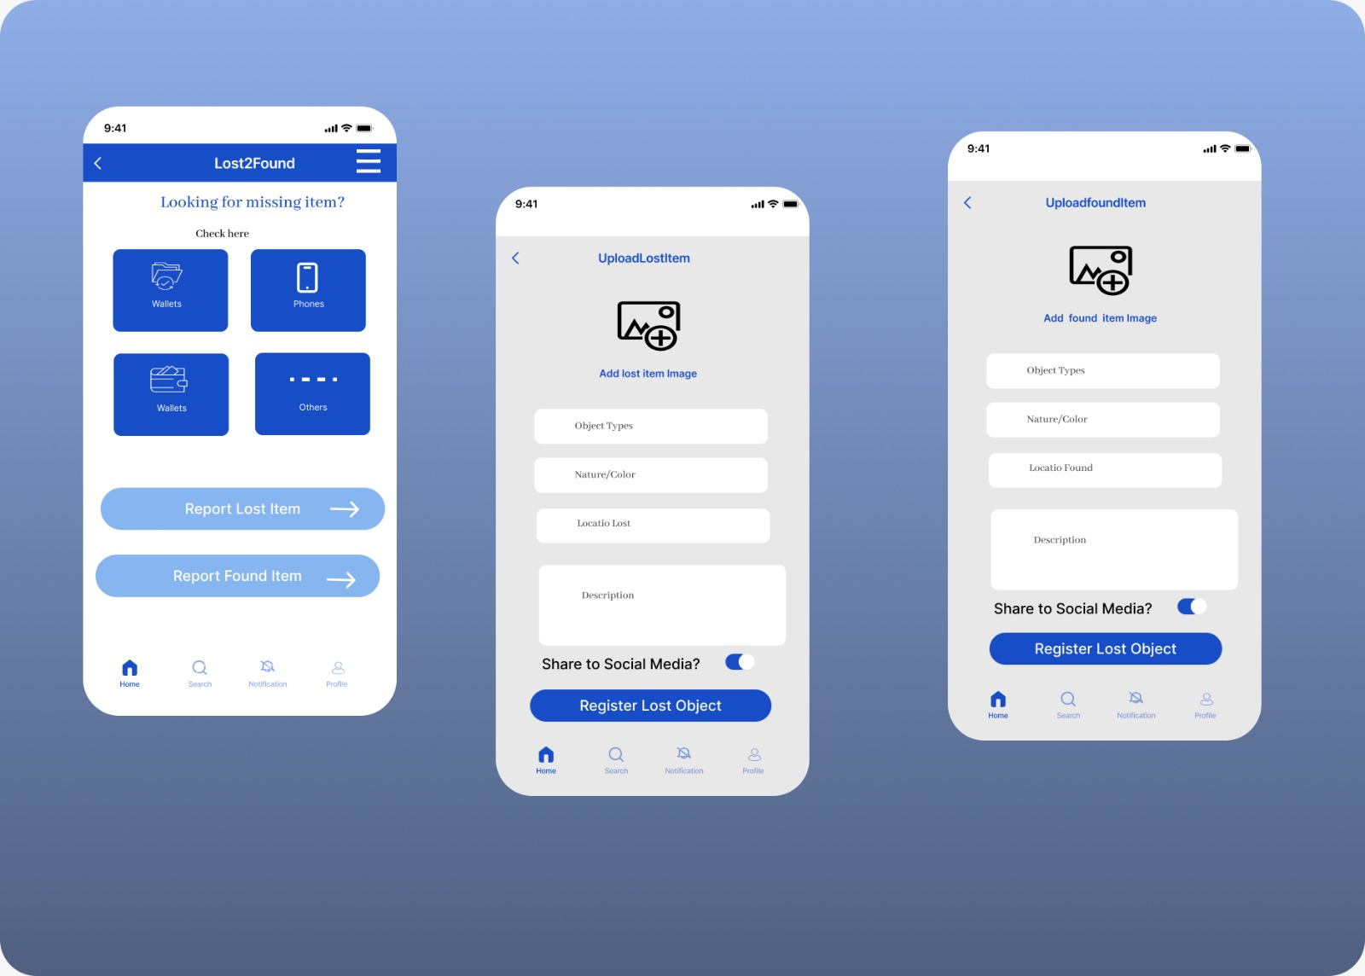

* Menu bar

With the menu button found on the top right corner of the home page for easy visibility without disruptions to the app includes buttons leading to the home, profile, notification, search, help, about us and contact us pages. With minimal words and colors for easy understanding.

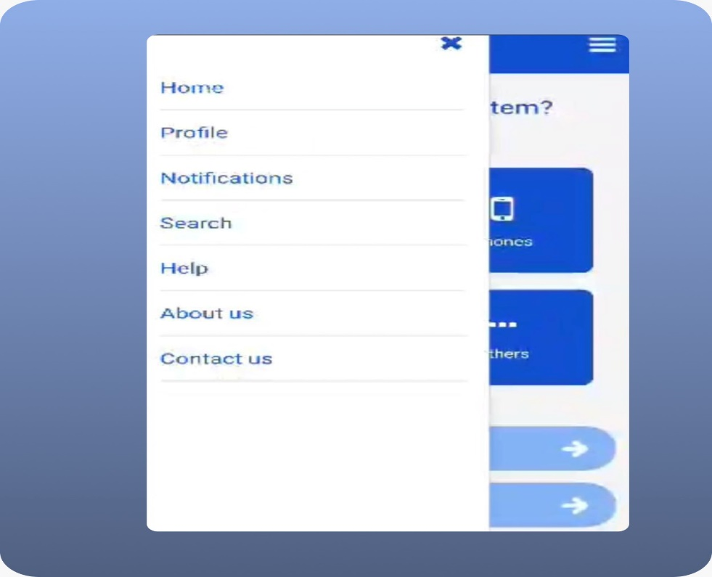

* Profile page

This page user’s personal and public information including a profile picture or nil, email address, username, phone number and address with minimal colors

* Search page

With clear instructions on the search bar *search for lost or found item ,* this page is meant for the search and display of items already registered on the database.

* Notification page

This page where all message sent from the application to the user are found which will include the image and description of a potential found item which might bgelong to said user

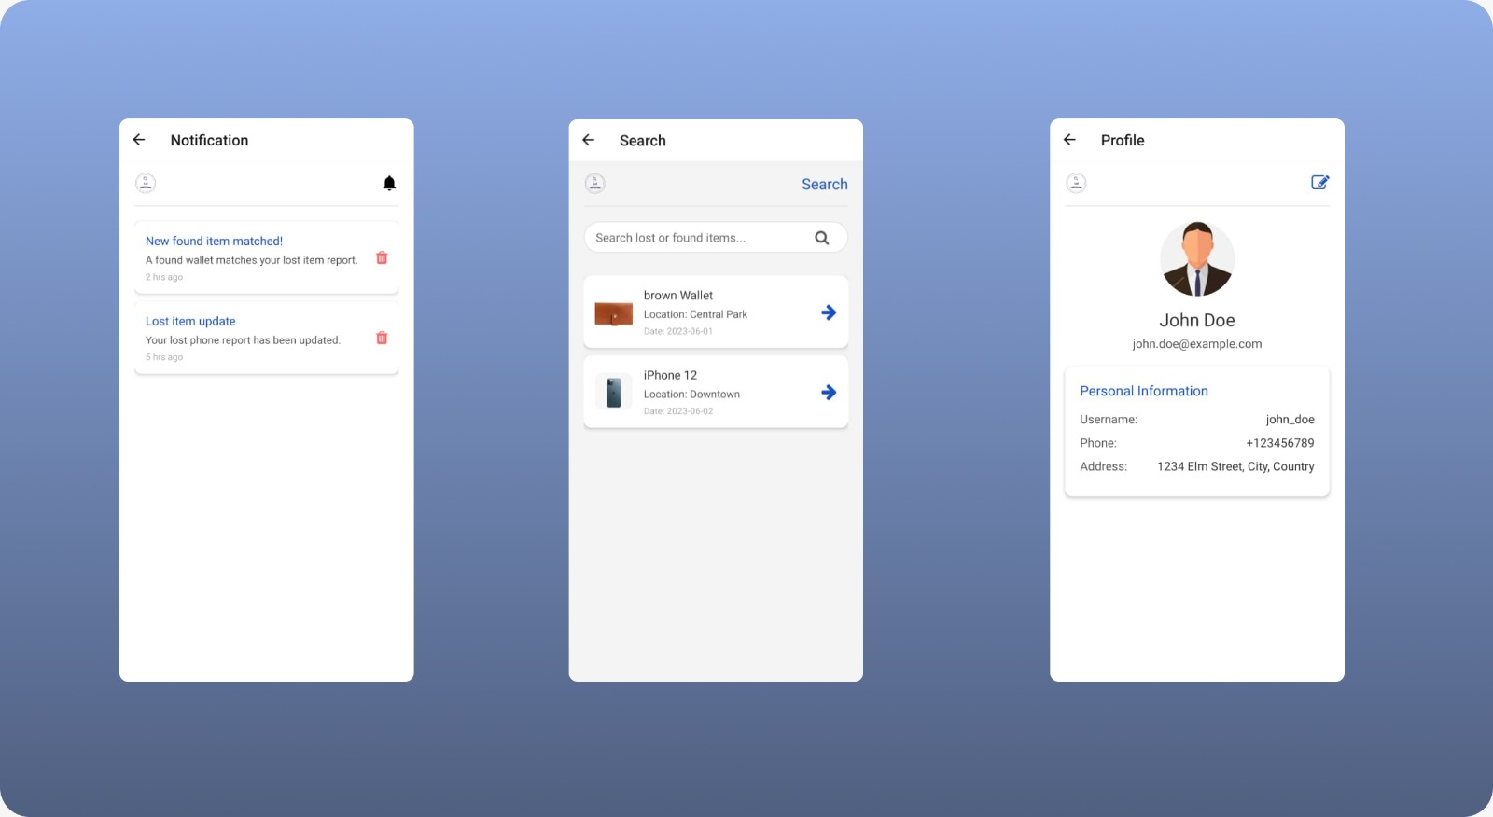

* Help page

This page includes a user-friendly image representing customer support/communication, also *frequently asked questions* to make the user more comfortable in asking their own questions. This page also includes the app’s contact information to render more help to the user if needed.

* About page

With an image representing “search” reminding users of the app’s purpose, this page also includes more and detailed information about the app’s purpose

* Contact us page

Being simple and clear, this page simple offers the user the app’s contact information (email) to the user and give them the opportunity to send their message/feedback/complaint directly.

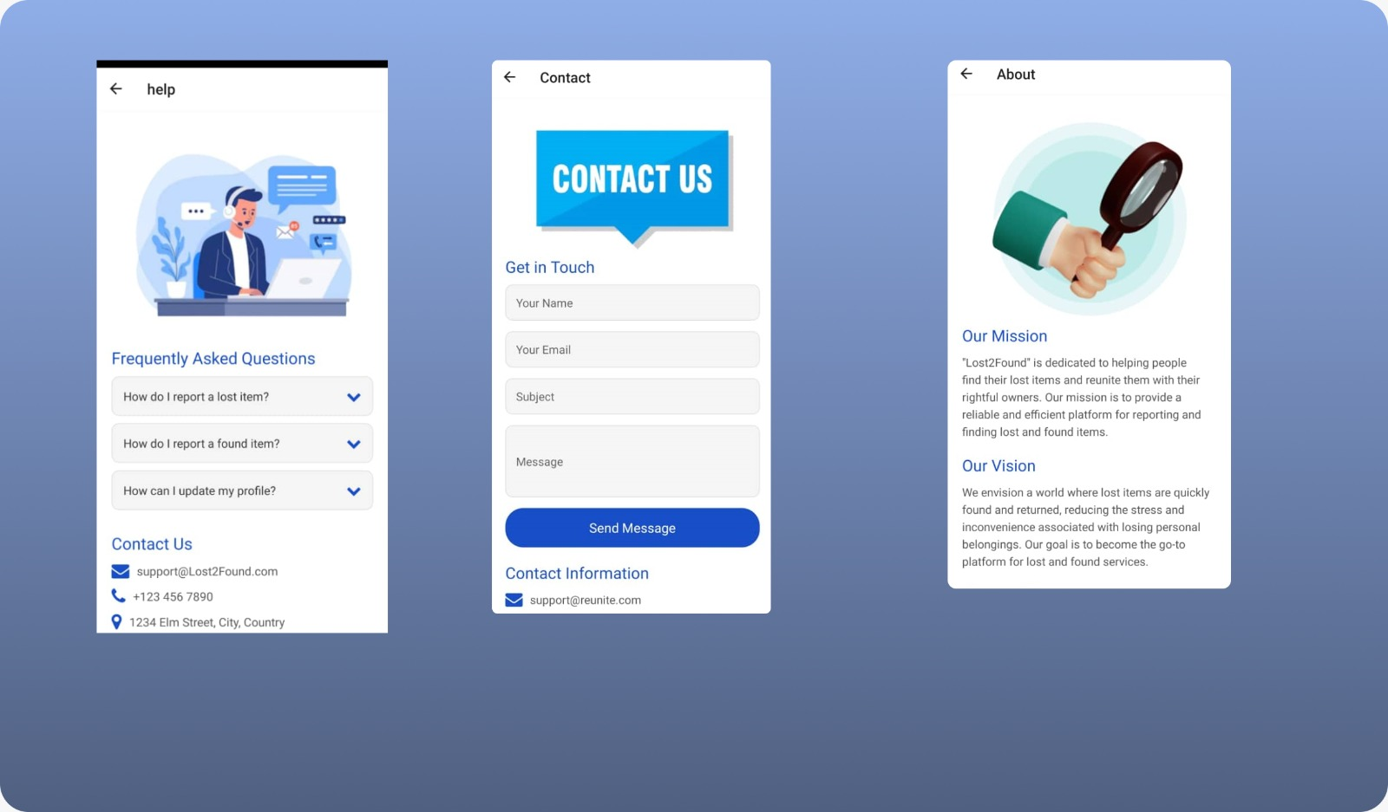

1. **IMPLEMENTATION**

Tools and Technologies

In this project, we utilized a variety of tools and technologies to build a cross-platform mobile application for archiving and retrieving missing objects.

Key tools and technologies used include:

React Native: A popular framework for building native mobile applications using JavaScript and React.

Expo: A set of tools and services built around React Native, which makes development, building, and deploying React Native applications easier.

React Navigation: A library for routing and navigation in React Native applications.

Vector Icons: We used react-native-vector-icons to include various icons, such as FontAwesome icons, in the app.

Expo ImagePicker: A library for selecting images from the device's library or camera.

Expo Sharing: A library for sharing content with other applications.

Navigation

Navigation in this project is handled using the React Navigation library. The setup allows seamless navigation between different screens in the application. The AppNavigator.js file configures the navigation stack:

Example from the AppNavigator.js page

Form Handling

Form handling in this project involves capturing user input through various form fields and processing the input upon form submission. We use React's useState hook to manage form data and handle submission logic within each relevant component

Example for the signInSignUp.js page,

Image Uploading

Image uploading is implemented using the Expo ImagePicker library. This allows users to select images from their device's gallery or take new photos using the camera. The selected image is then displayed in the image picker component, and users can change the image by clicking on the image picker again.

Example from UploadLostImagePage.js:

Notification System

For the notification system, we used Expo's Notifications API. This API allows us to handle both local and push notifications. Here’s how we set up the notifications:

expo install expo-notifications

1. **Conclusion:**

The chosen color scheme, typography amongst others directly supports the app's functionality. By fostering trust and calmness, users are more likely to engage with the app effectively. Clear visual distinctions help users quickly identify and utilize key features, such as reporting lost items or browsing found items. The overall user-friendly interface ensures that users can focus on their primary goal finding their missing items.

The blue, white and sky blue color scheme is a deliberate choice to enhance usability, instill trust, and provide a calm and professional environment for users of the "Lost 2 Found" app.

In conclusion, the design and implementation of the UI for the app for archival and retrieval of missing items via image matching involved thorough research, conceptualization, and development. By focusing on user needs and preferences. Future enhancements and optimizations will continue to improve the app's functionality and user experience.

**THANK YOU**